**Interprofessional Health Promotion Challenge**

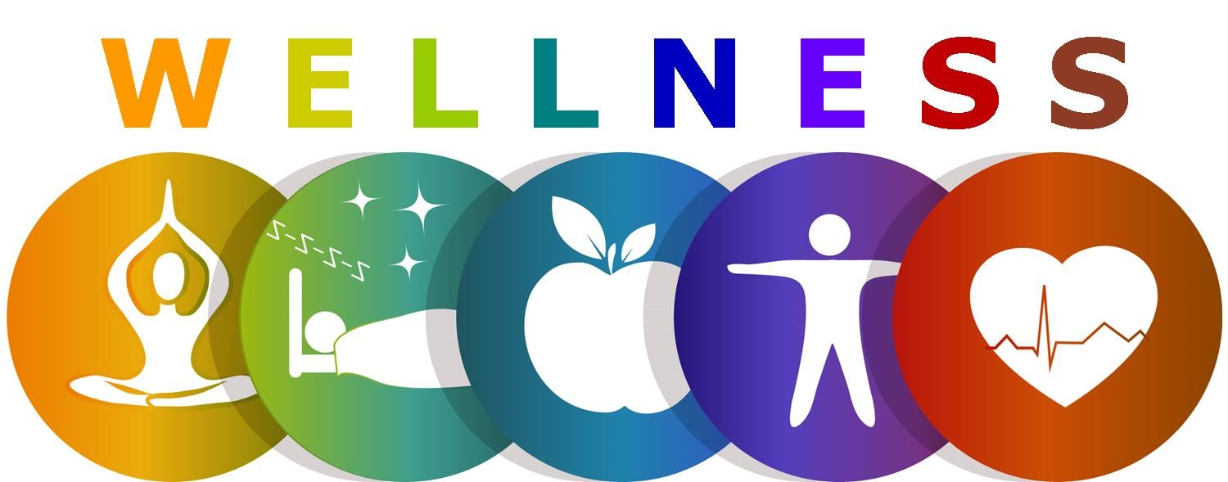

The spring semester will be spent planning a Health Promotion Proposal that is multifaceted, interdisciplinary, innovative, evidenced-based, feasible and sustainable intervention that is implement-ready by the community to address the health-related disparity that was identified in the Fall. Proposals should prioritize the specific health effects and causal factors to be addressed, justify the choice of intervention(s), specify the implementation and evaluation strategy, and provide budget estimates for the use of funds within the time frame specified.

Task: Develop a feasible and creative proposal of an intervention or interventions that will aid in the prevention and control of the health-related disparity identified for your community. Present your proposed health promotion solution(s) as part of the IPE Health Promotion Challenge competition to be held on **April 26, 2022**.

Scope: The proposal is limited to a budget of $2.5 million USD to be used during a 5-year span. Your proposal and presentation should apply the information learned through the community scan and address the health-related disparity, the groups of people targeted by the Health Promotion Proposal, and/or organizations your intervention(s) will engage and provide a justification for these selections. Staff salaries for the intervention should be covered within the allowed budget.

Presentation: The presentation should last 8 minutes with 2 minutes for questions. The following sections should be included:

* Background/Statement of Need
* Goal
* Intended Outcomes
* Intervention Strategy/Mechanism/Details
* Sustainability
* Potential Community Partners
* Budget Overview
* Potential Barriers and Responses
* Conclusion

Judging: In evaluating the proposed case solutions, the following will be considered:

* Rationale/Justification for strategies
* Specificity and feasibility
* Interdisciplinary nature of the solution
* Creativity and innovation
* Clarity and organization
* Presentation delivery
* Teamwork
* Ability to respond to questions

Challenge Day Agenda:

Timeline Activity

9:00 – 9:05 Welcome

9:05 – 9:15 Team 1

9:20 – 9:30 Team 2

9:35 – 9:45 Team 3

9:50 – 10:00 Team 4

10:00 – 10:10 Break

10:10 – 10:20 Team 5

10:25 – 10:35 Team 6

10:40 – 10:50 Team 7

10:50 – 11:00 Break

11:00 – 11:10 Team 8

11:15 – 11:25 Team 9

11:30 – 11:40 Team 10

11:40 – 11:50 Judge Review

11:50 Announce Winning Team